Aim:
Lapindrome is defined as a string which when split in the middle, gives two halves having the same characters and same frequency of each character. If there are odd number of characters in the string, we ignore the middle character and check for lapindrome. For example gaga is a lapindrome, since the two halves ga and ga have the same characters with same frequency. Also, abccab, rotor and xyzxy are a few examples of lapindromes. Note that abbaab is NOT a lapindrome. The two halves contain the same characters but their frequencies do not match.
Your task is simple. Given a string, you need to tell if it is a lapindrome.
Input:
First line of input contains a single integerT, the number of test cases.
Each test is a single line containing a stringScomposed of only lowercase English alphabet.
Program:
import java.util.*;
public class Main {
public static void main(String[] args) {
Scanner sc = new Scanner(System.in);
int t = sc.nextInt();
while (t-- > 0) {
String s = sc.next();
int n = s.length();
int[] freq = new int[26];
for (int i = 0; i < n / 2; i++) {
freq[s.charAt(i) - 'a']++;
}
for (int i = (n + 1) / 2; i < n; i++) {
freq[s.charAt(i) - 'a']--;
}
boolean isLapindrome = true;
for (int count : freq) {
if (count != 0) {
isLapindrome = false;
break;
}
}
System.out.println(isLapindrome ? "YES" : "NO");
}
sc.close();
}
}

Output:
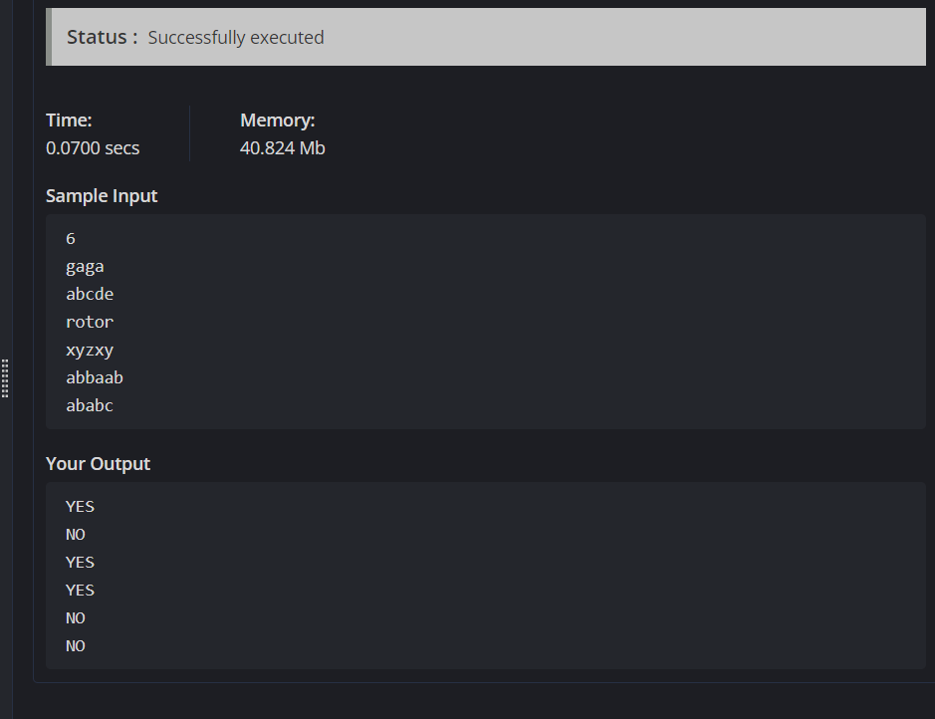

Task 2:
Aim: You are given a string s of even length. Split this string into two halves of equal lengths, and let a be the first half and b be the second half.Two strings are alike if they have the same number of vowels ('a', 'e', 'i', 'o', 'u', 'A', 'E', 'I', 'O', 'U'). Notice that s contains uppercase and lowercase letters.Return true if a and b are alike. Otherwise, return false.
Example 1:
Input: s = "book"
Output: true
Explanation: a = "bo" and b = "ok". a has 1 vowel and b has 1 vowel. Therefore, they are alike.
Example 2:
Input: s = "textbook"
Output: false
Explanation: a = "text" and b = "book". a has 1 vowel whereas b has 2. Therefore, they are not alike.
Notice that the vowel o is counted twice.
Program:
class Solution {
public boolean halvesAreAlike(String s) {
int n = s.length();
String vowels = "aeiouAEIOU";
int countA = 0, countB = 0;
for (int i = 0; i < n / 2; i++) {
if (vowels.indexOf(s.charAt(i)) != -1) {
countA++;
}
}
for (int i = n / 2; i < n; i++) {
if (vowels.indexOf(s.charAt(i)) != -1) {
countB++;
}
}
return countA == countB;
}
}
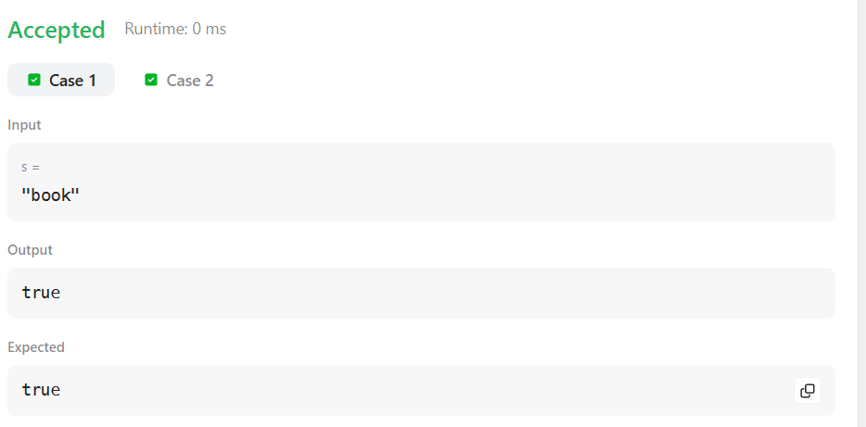
Output:

